**Assignment – 1**

For this Assignment, I will be using the R studio to complete the task. Here, I will be performing data cleaning and data visualization.

Step1:

A) Here we are reading the csv file using read.csv(), then displaying the dataset using the View function.

B) To check the dimensions, I am using the dim() function.

C) Now, I am trying to build a new data frame by using the function as.data.frame and then display the data and displaying the summary of the data using summary function. By using the summary function, I was able to even check if there are any NA values as well.

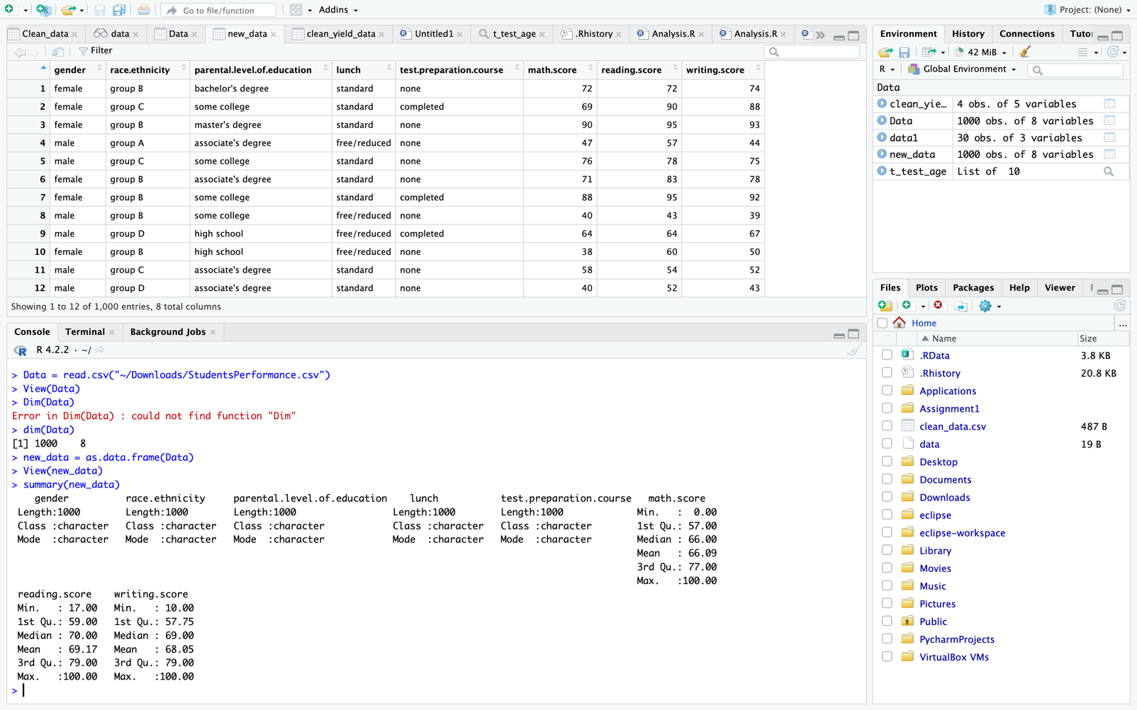

No NA values found in the summary.

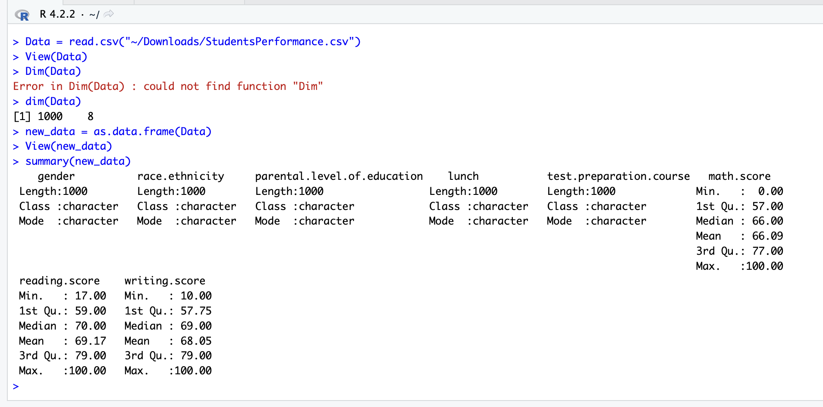

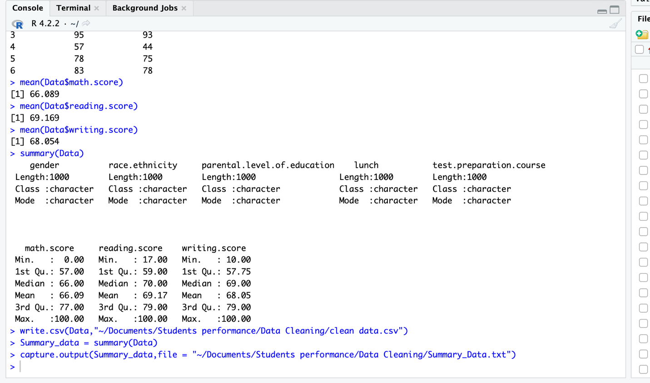

Step2: Here I am checking the data and exploring the categorical data using table function()

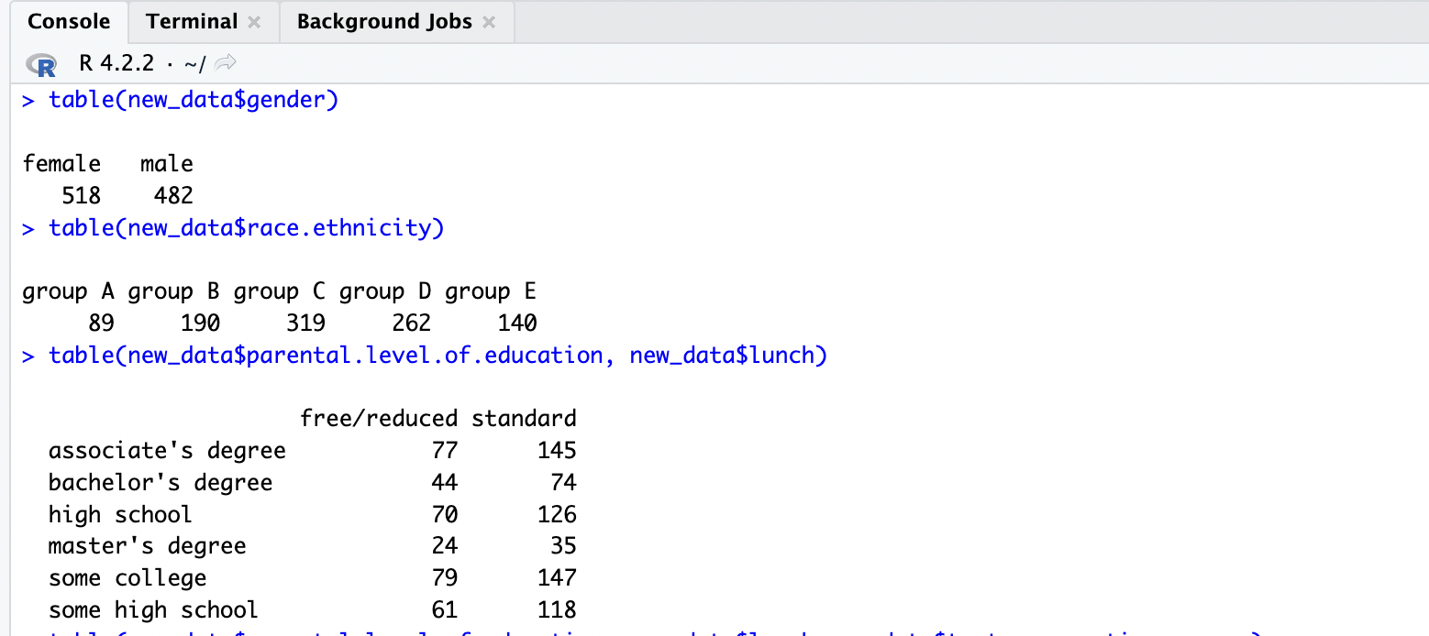

Step3: Here, I am finding the mean of few fields and then store the output.



Data Visualization:

Figure1:

Here, we are going to perform the data Visualization for the writing score and the gender using box plot function. Here we are installing the package ggplot2 then we will call the package using the function library. Then we plot the graphs as below

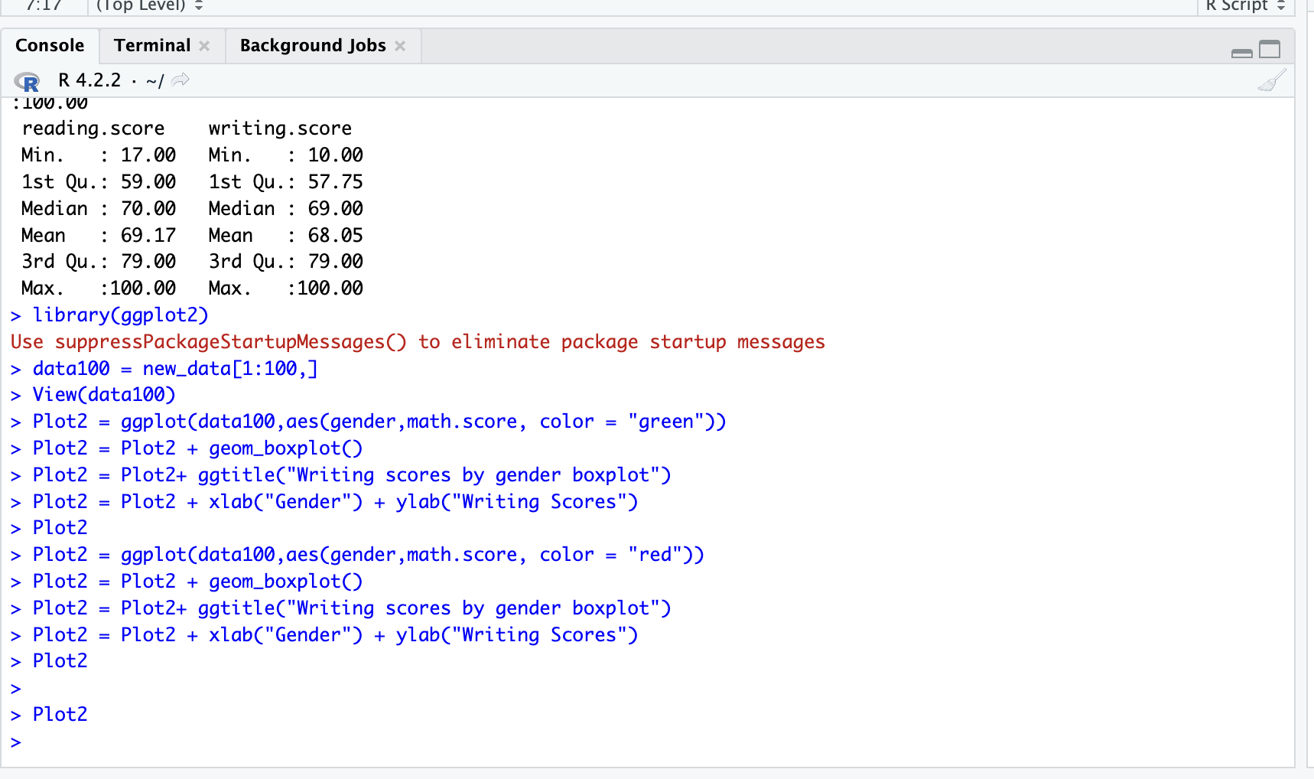

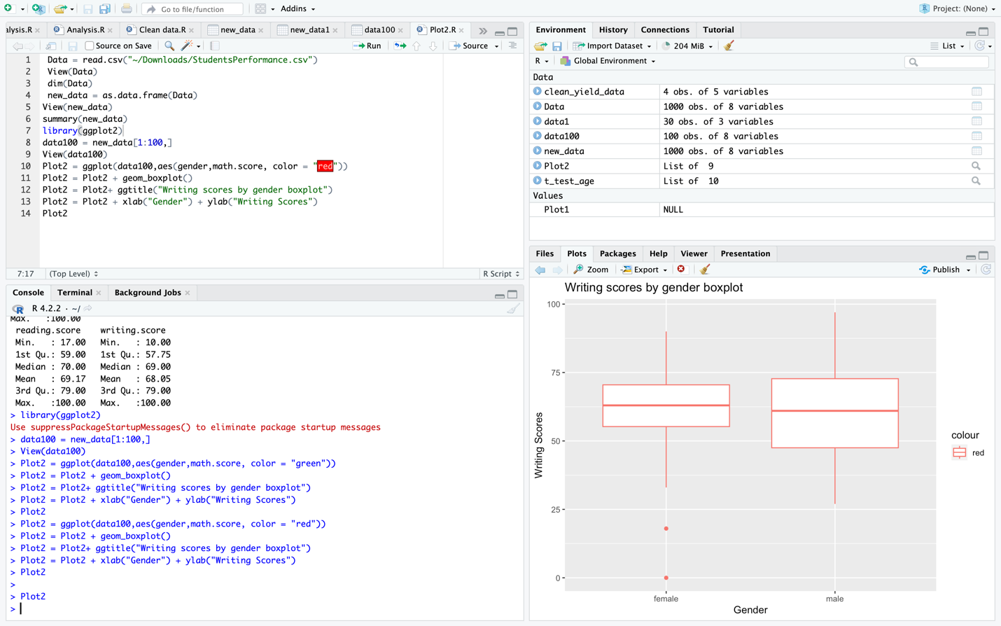

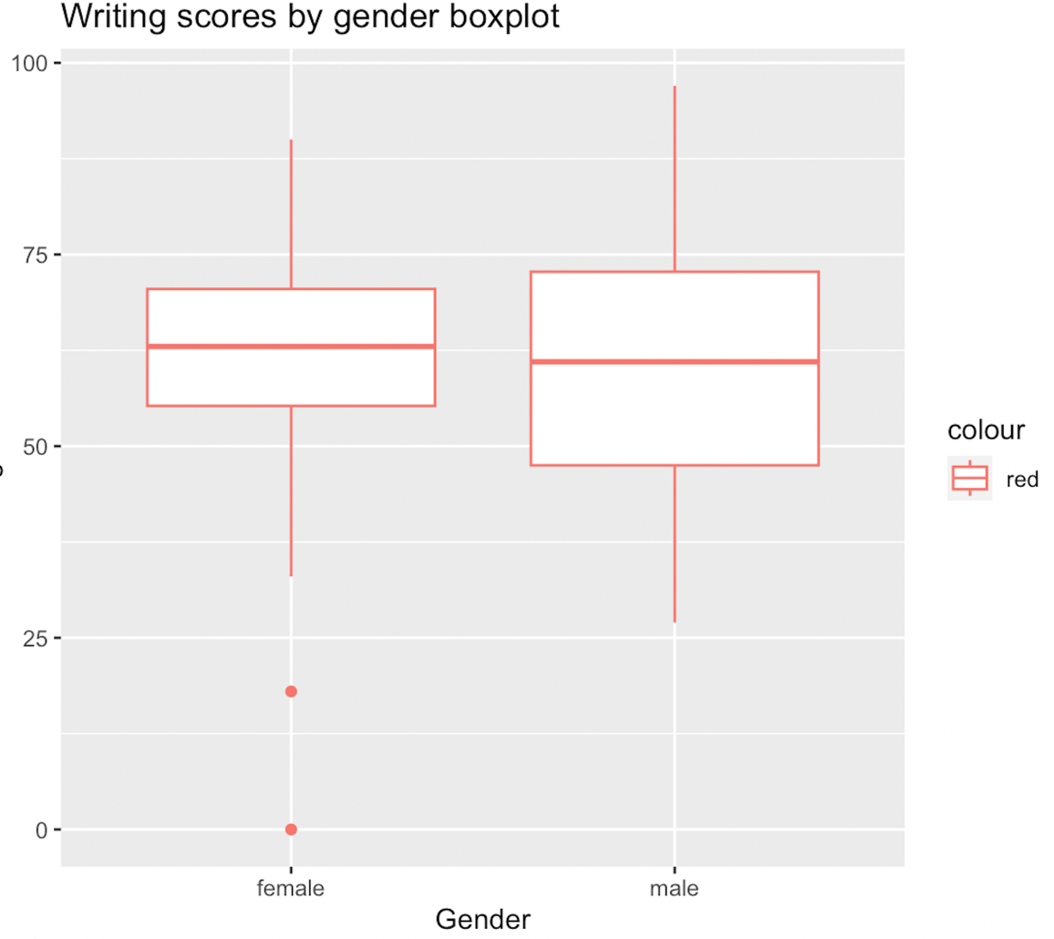

Figure2:

Here, we are going to perform the data Visualization for the Maths score and the gender using ggplot and histogram function. Here we are installing the package ggplot2 then we will call the package using the function library. Then we plot the graphs as below

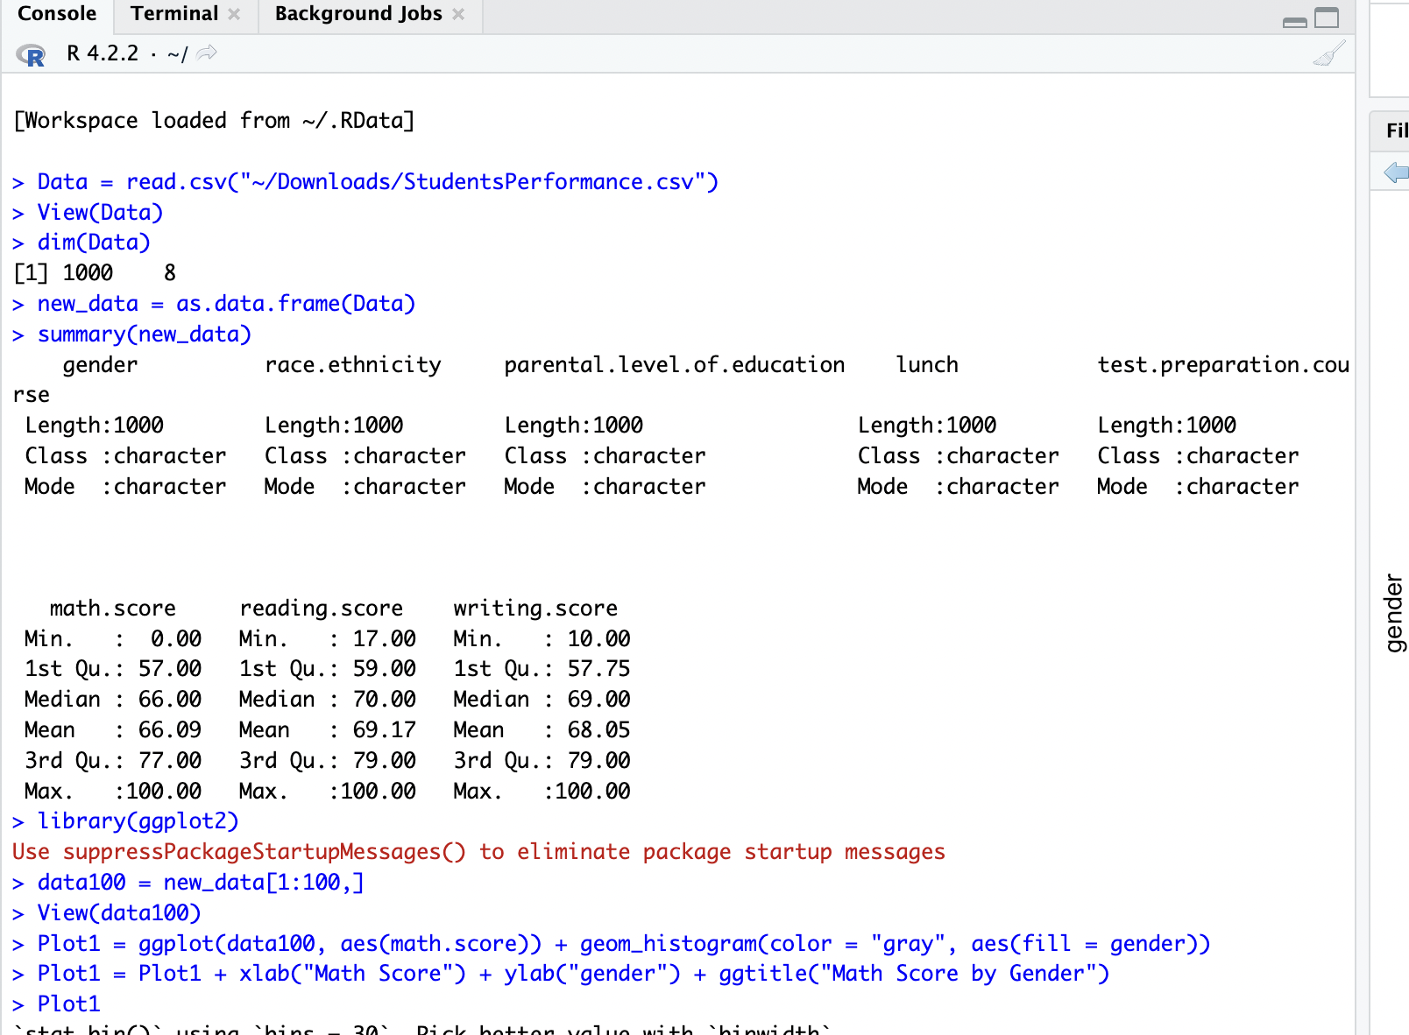

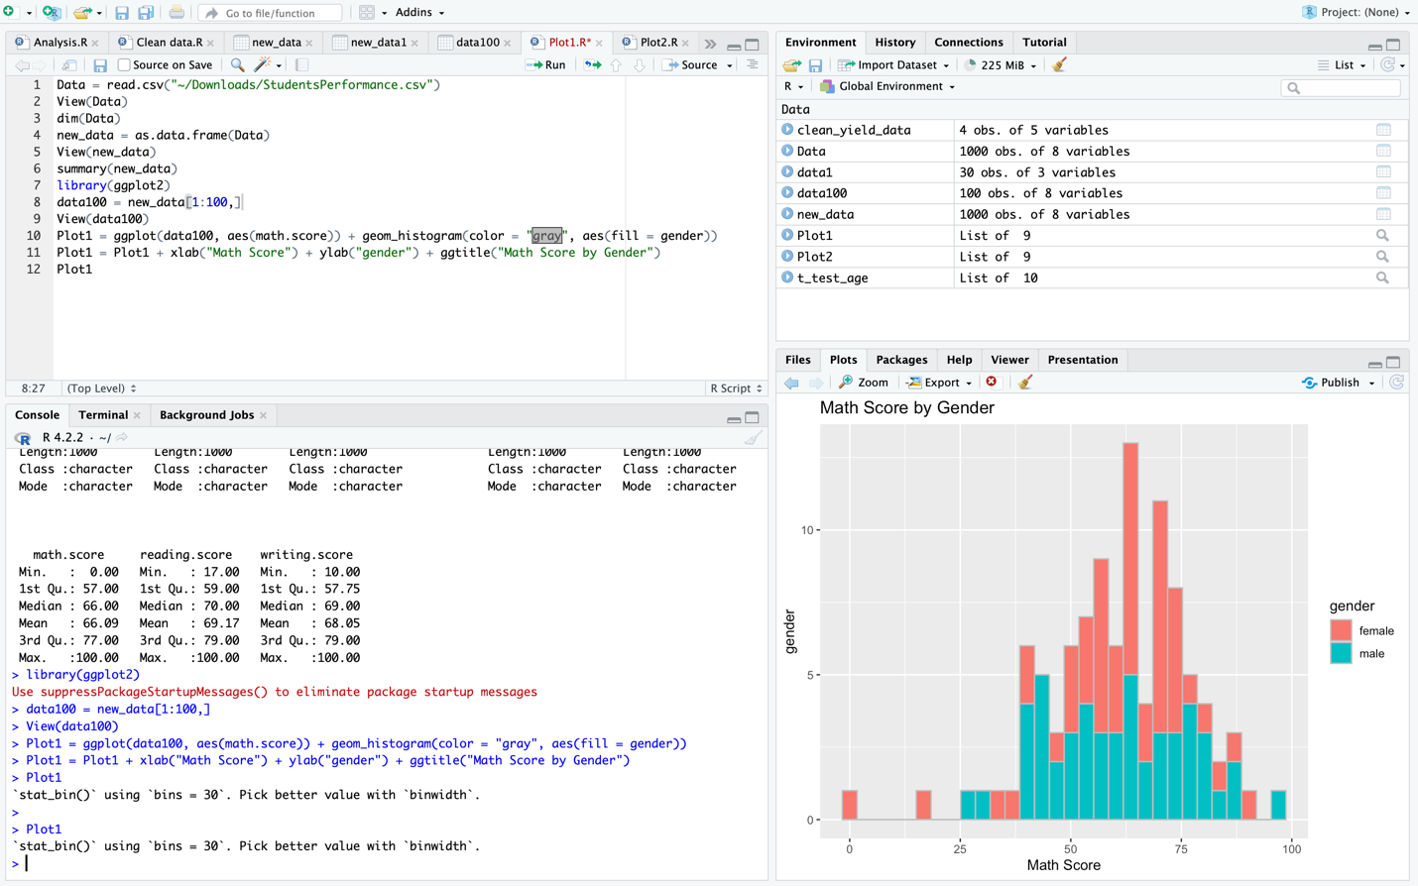

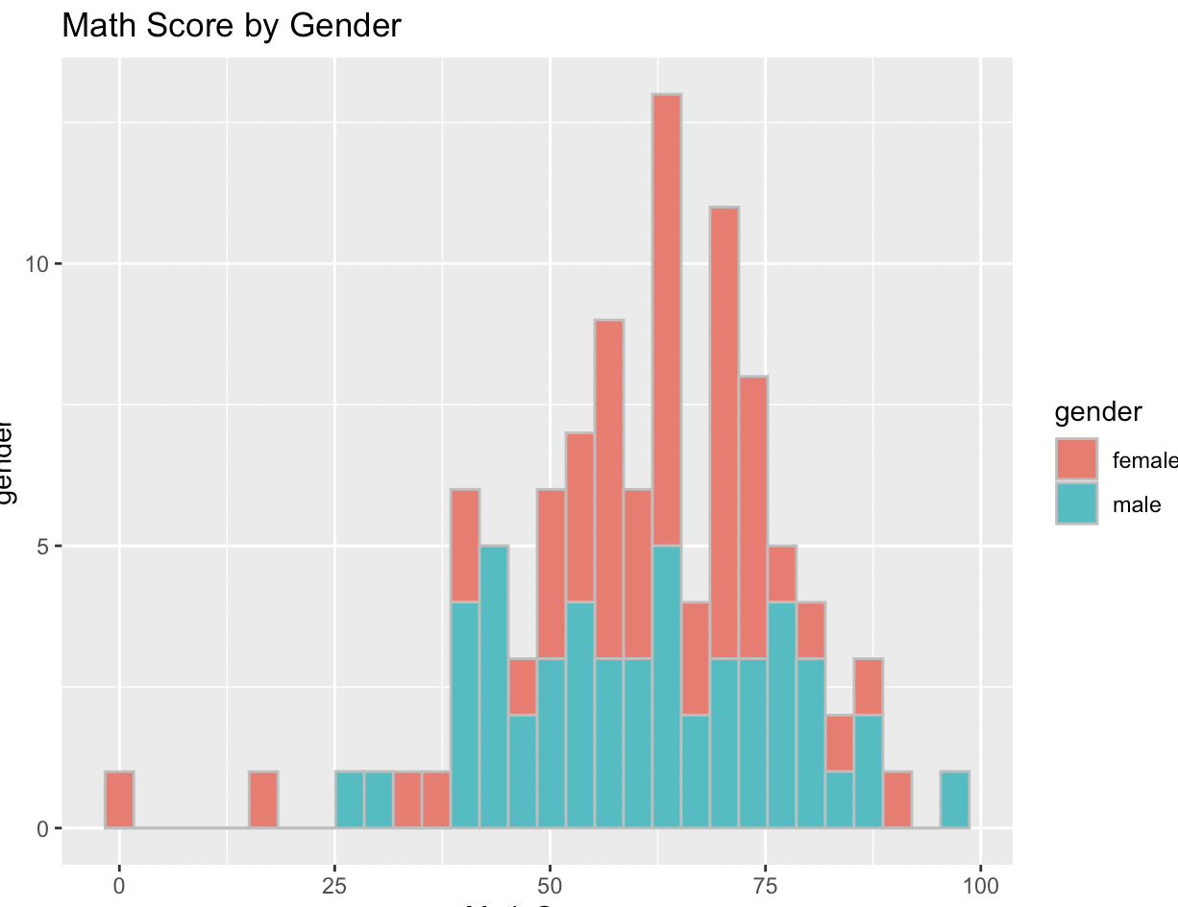

Figure3:

Here, we are going to perform the data Visualization for the Writing score and the parental education using ggplot and geom_bind2d function. Here we are installing the package ggplot2 then we will call the package using the function library. Then we plot the graphs as below

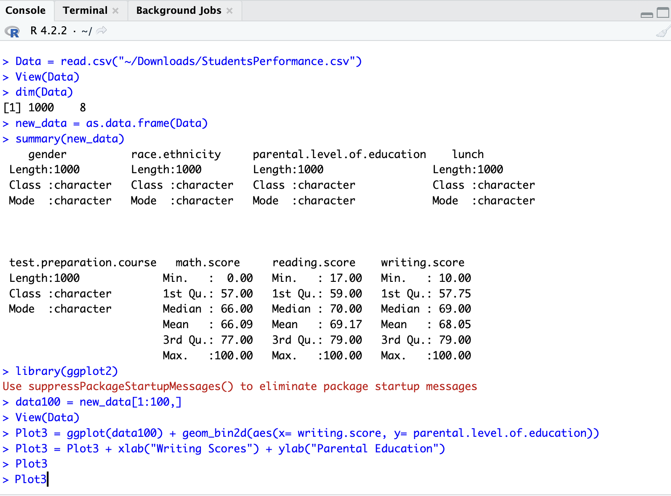

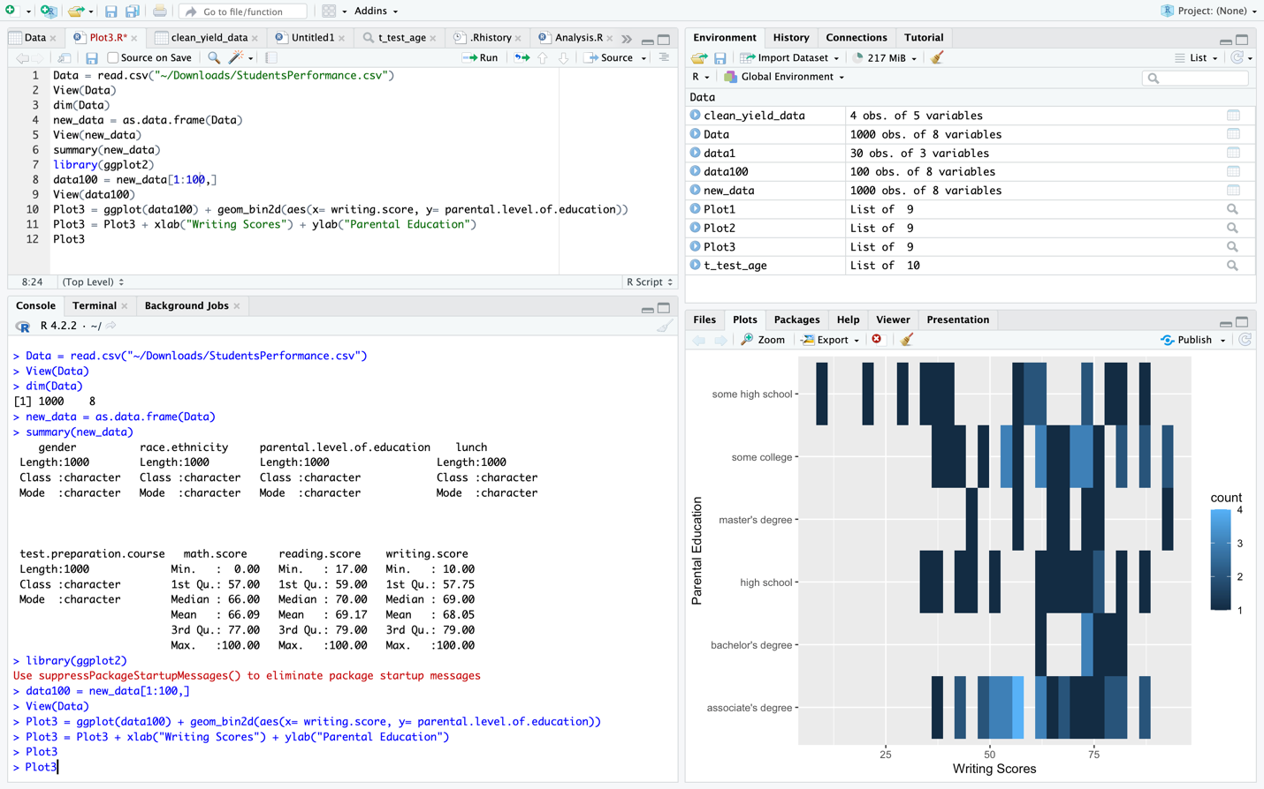

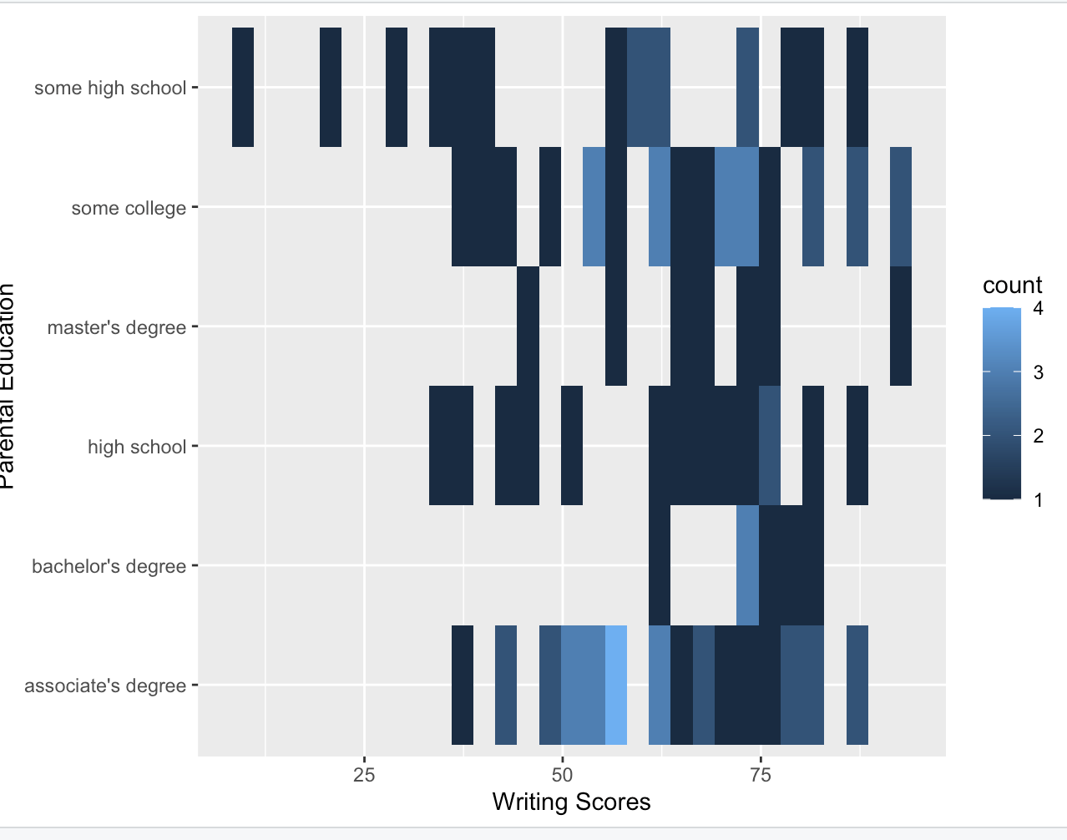

Figure4:

Here, we are going to perform the data Visualization for the Math score and the parental education using ggplot and geom_smoth and grom_point function. Here we are installing the package ggplot2 then we will call the package using the function library. Then we plot the graphs as below

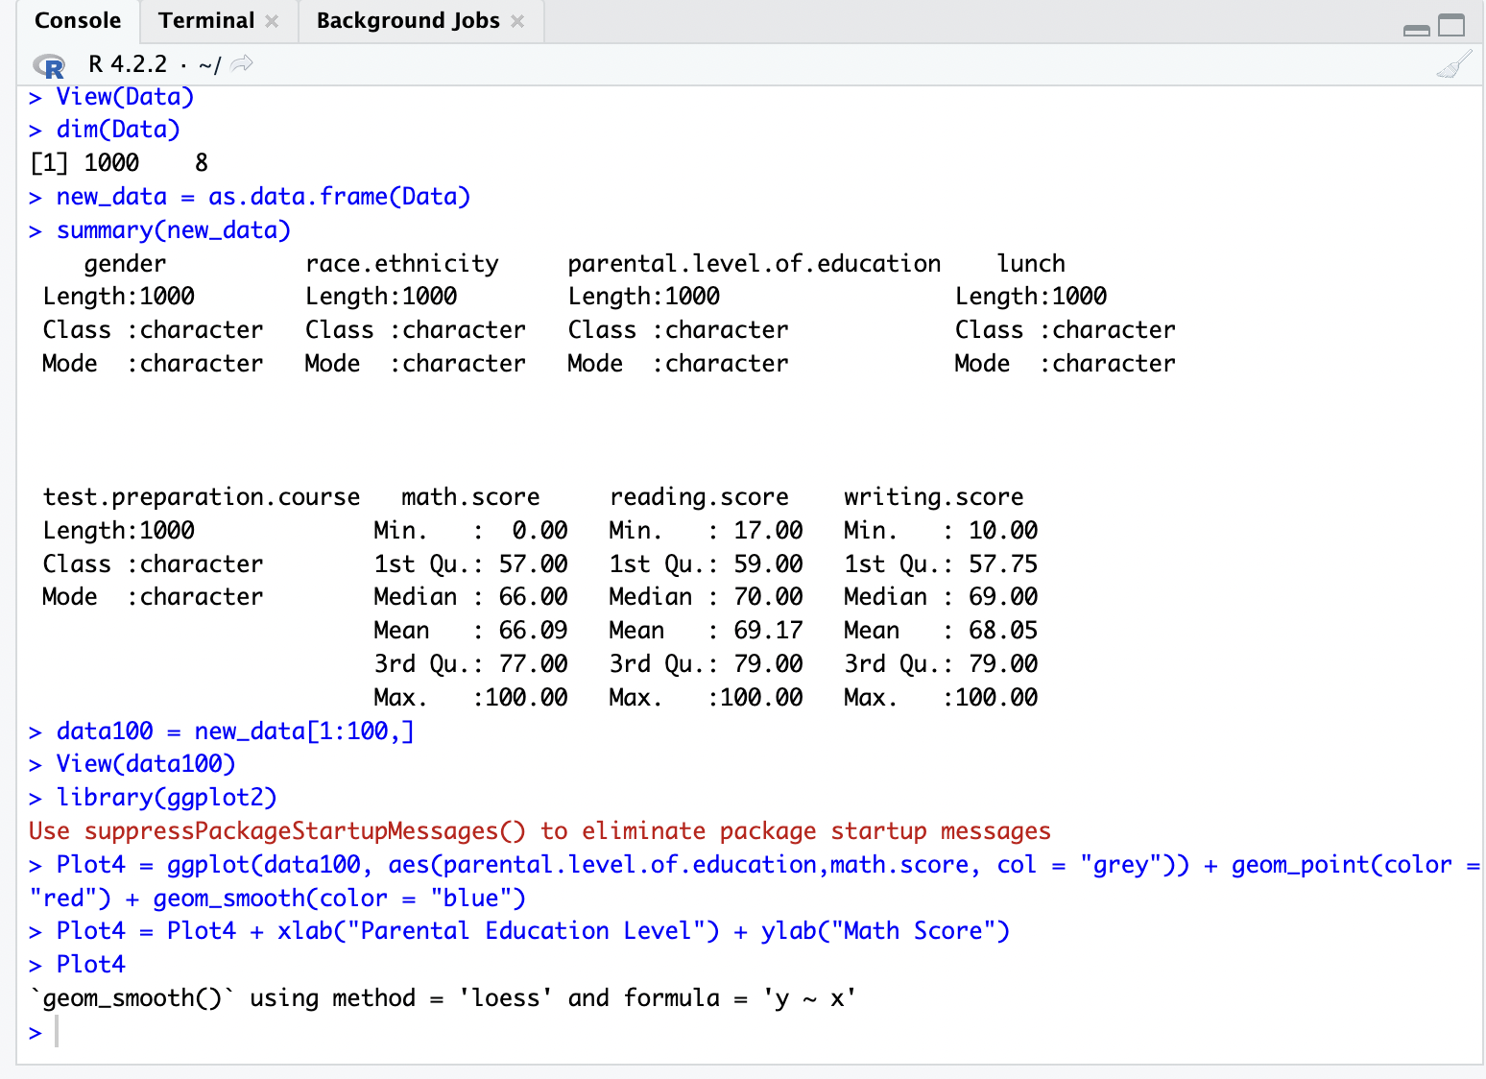

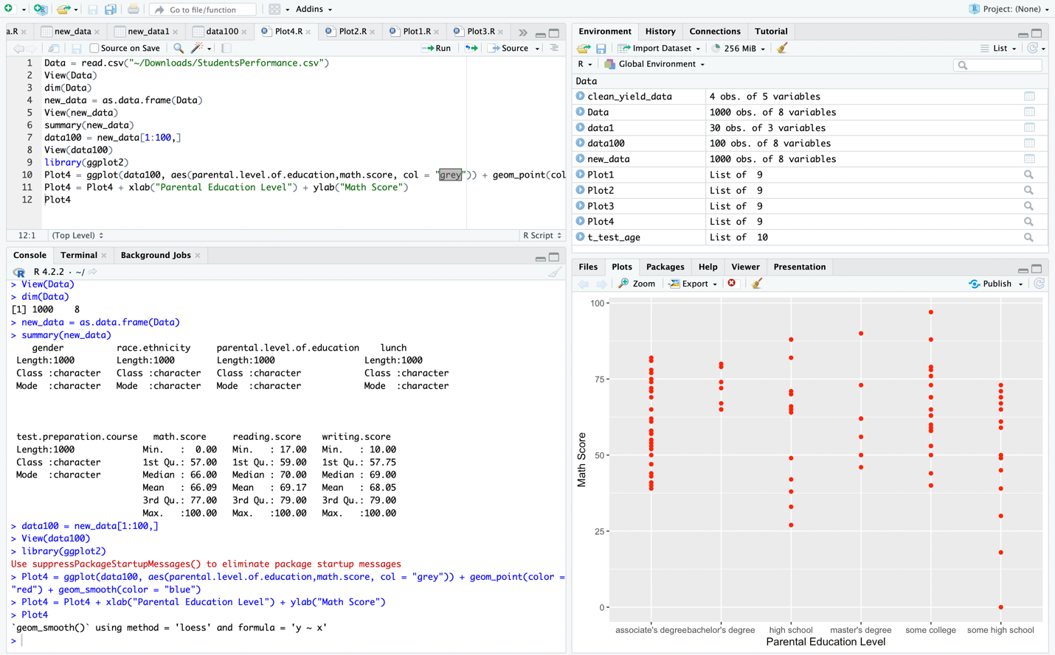

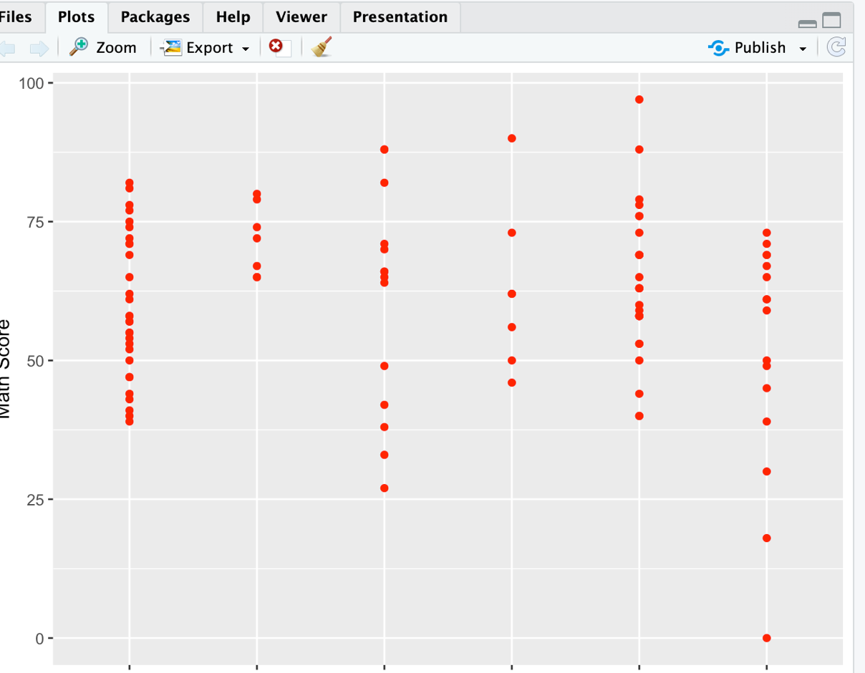

Figure5:

Here, we are going to perform the data Visualization for the Math score and the race ethnicity using ggplot and geom_bar and coord_polar function. Here we are installing the package ggplot2 then we will call the package using the function library. Then we plot the graphs as below

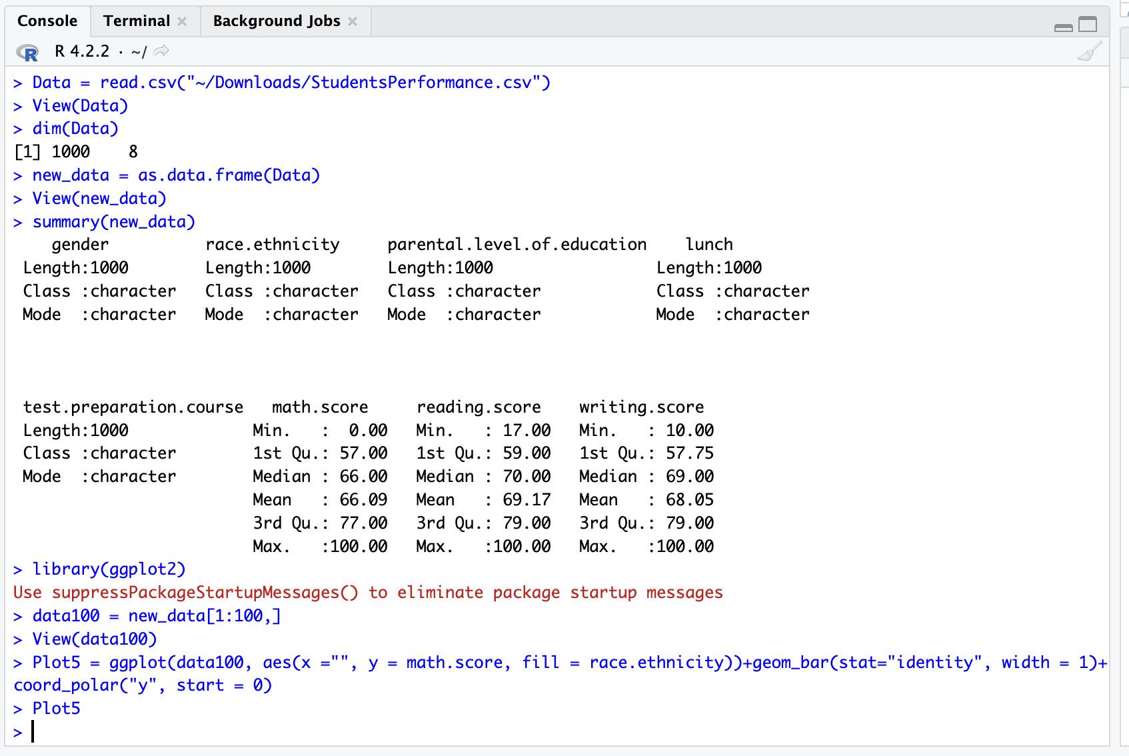

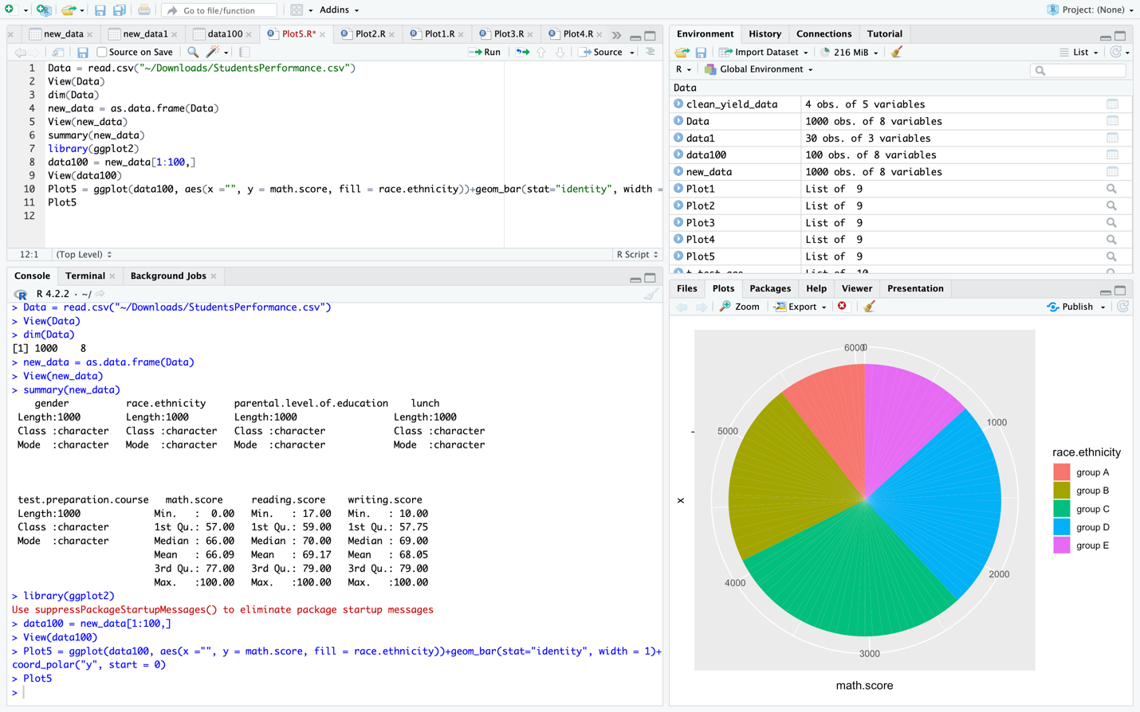

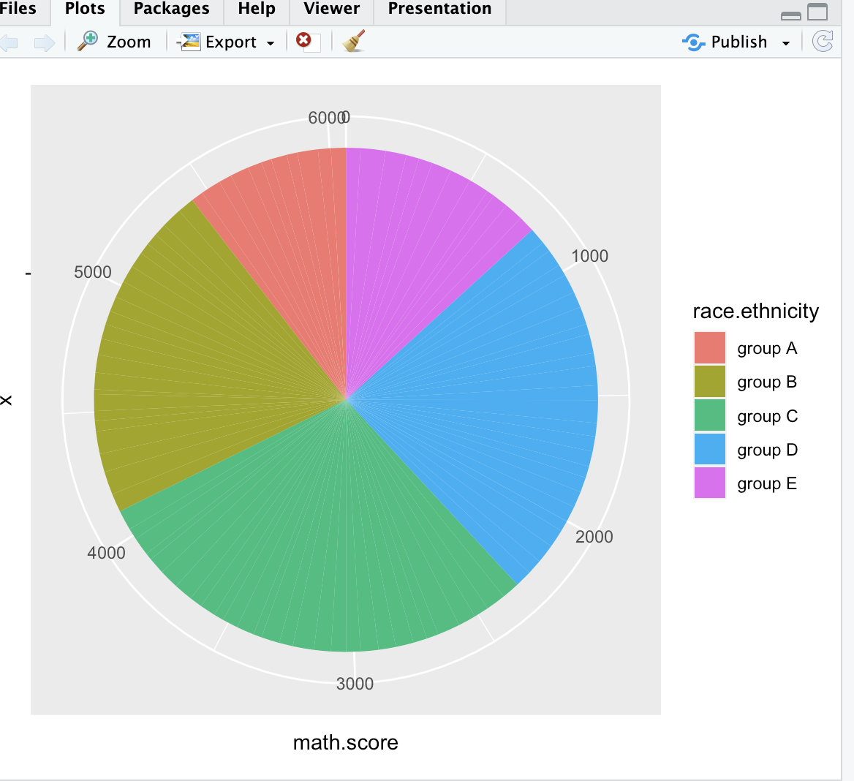

**Summary**: Out of all the data visualization, ggplot with the boxplot was easier compared to all other visualizations. Whereas other techniques are good in display and difficult to code and understand. With this assignment I was able to gain good knowledge on data cleaning, data visualization and use of R studio.